

Alert No 02/2016

**Safety Alert**

**Burn to Operative from Flame Gun Resulted in an over 7 day RIDDOR.**

The IP, a road worker/fitter working on the Micro-asphalt operation for the Surface Treatments Business was washing out the laying box with the jet washer. Whilst doing so the IP didn't see the burning lamp used to heat the asphalt and he bumped into it.

The micro asphalt laying box had become heavily contaminated with dried on bitumen emulsion. An operative was cleaning it using a combination of heat from a propane hand held torch and high pressure water from the built in jet washer.

The method of operation for the gas torch should be that a knurled nut control valve is used to control the gas supply to maintain a small pilot flame and a trigger mechanism is then depressed to provide extra gas and hence a hotter and larger flame when in use.

This safety alert has been prepared by the RSTA. Completed forms for adding to the RSTA website should be submitted to [Kathy@rsta-uk.org](mailto:Kathy@rsta-uk.org) further information regarding this safety alert please email Kathy or

phone 01902 824 325



Alert No 02/2016

**Safety Alert**

Whilst using the propane torch the operative turned the control valve fully on which meant that the flame was left on full power flame regardless of the trigger position. The operative dropped the torch and the weight of the hose caused the torch to flick round. The flame (which is around 1000°C) passed across the operative’s torso just under his loose fitting PPE, causing burns to a large area of the operative’s lower trunk.



If the trigger had been adjusted correctly the gas would have been cut off almost entirely when the torch was dropped and it is unlikely that any injury would have occurred

**Action taken to prevent reoccurrence**

* Operatives have been re-trained on safe use of propane heating equipment.

This safety alert has been prepared by the RSTA. Completed forms for adding to the RSTA website should be submitted to Kathy@rsta-uk.org further information regarding this safety alert please email Kathy or

phone 01902 824 325



Alert No 02/2016

This safety alert has been prepared by the RSTA. Completed forms for adding to the RSTA website should be submitted to Kathy@rsta-uk.org further information regarding this safety alert please email Kathy or

phone 01902 824 325

**Safety Alert**

* A new fail safe design of torch has been supplied with a piezo igniter built in to the trigger mechanism so that any flame is totally extinguished whenever the torch is put down or dropped.

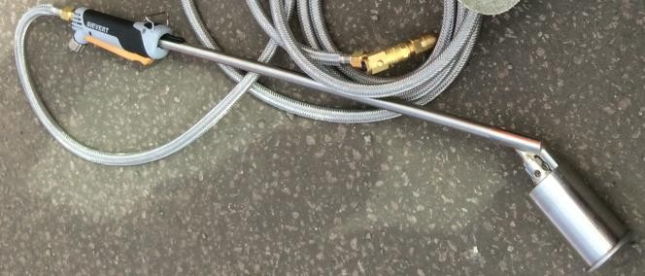

* Operatives using the torch have also been issued with new flame retardant PPE which covers all exposed skin.